Week 1

Introduction to Servlet, JSP and MySQL Database

Web Based Application Development

Lecturers

PUSAT PENGAJIAN INFORMATIK DAN MATEMATIK GUNAAN (PPIMG), UNIVERSITI MALAYSIA TERENGGANU (UMT)

# Revision History

|  |  |  |  |
| --- | --- | --- | --- |
| **Revision Date** | **Previous Revision Date** | **Summary of Changes** | **Changes Marked** |
|  |  | First Issue | Mohamad Nor Hassan |
|  |  | Second Issue | Dr Rabiei Mamat Dr Faizah Aplop Dr Fouad  Ts Dr Rosmayati Mohemad Fakhrul Adli Mohd Zaki |
| 21/02/2019 |  | Addition of Revision History, Table of Contents, Formatting Cover Page | Fakhrul Adli Mohd Zaki |
| 24/02/2019 | 21/02/2019 | Updated Task 1, English translation for the instruction, Addition of Java Servlet task. Fix spelling and grammar. | Fakhrul Adli Mohd Zaki |
| 30/3/2021 |  | Added “Troubleshooting Notes: Fixing phpMyAdmin Error” Added new topic “Managing Apache Tomcat”  Added new topic “Netbeans 12.3 IDE Installation”  Updated existing topic “Link Netbeans” to “Apache Tomcat and Writing a Simple Java Servlet”  Updated page numbers | Fakhrul Adli Mohd Zaki |

Table of Contents

Task 1: Apache Tomcat and MySQL Installation Using XAMPP 5

Task 2: Change the Default Root Password of MySQL Database 11

Task 3: Managing Apache Tomcat 18

Task 4: Netbeans 12.3 IDE Installation 22

Task 5: Linking Netbeans to Apache Tomcat and Writing a Simple Java Servlet

........................................................................................... 25

Task 6: Writing a Simple JSP Program 38

Task 7: Use Java Reference Datatype/Class Wrapper in JSP 44

Task 8: Using JSP Implicit object in JSP page 47

Task 9: Populate Array values into HTML’s Table 51

# Arahan:

Manual makmal ini adalah untuk kegunaan pelajar-pelajar Pusat Pengajian Informatik dan Matematik Gunaan (PPIMG), Universiti Malaysia Terengganu (UMT) sahaja. Tidak dibenarkan mencetak dan mengedar manual ini tanpa kebenaran rasmi daripada penulis.

Sila ikuti langkah demi langkah sebagaimana yang dinyatakan di dalam manual. Tandakan (√) setiap langkah yang telah selesai dibuat dan tulis kesimpulan bagi setiap aktiviti yang telah selesai dijalankan.

***Instruction:***

*This laboratory manual is for use by the students of the School of Informatics and Applied Mathematics (PPIMG), Universiti Malaysia Terengganu (UMT) only. It is not permissible to print and distribute this manual without the official authorisation of the author.*

*Please follow step by step as described in the manual. Tick (√) each step*

*completed and write the conclusions for each completed activity.*

**Task 1: Apache Tomcat and MySQL Installation Using XAMPP**

**Objective**

**Problem Description**

**Estimated time**

**:** Installation of Apache Tomcat and MySQL

**:** To install Apache Tomcat and MySQL

**:**

25 minutes

1. Go to the browser and type URL <http://www.apachefriends.org/en/xampp.html>
2. Click to XAMPP for Windows.

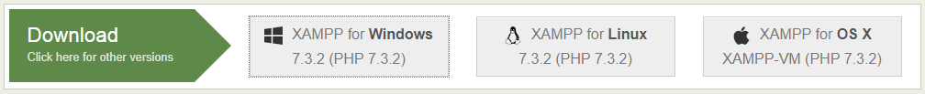

1. Save to a specific directory — for example, the Downloads folder.

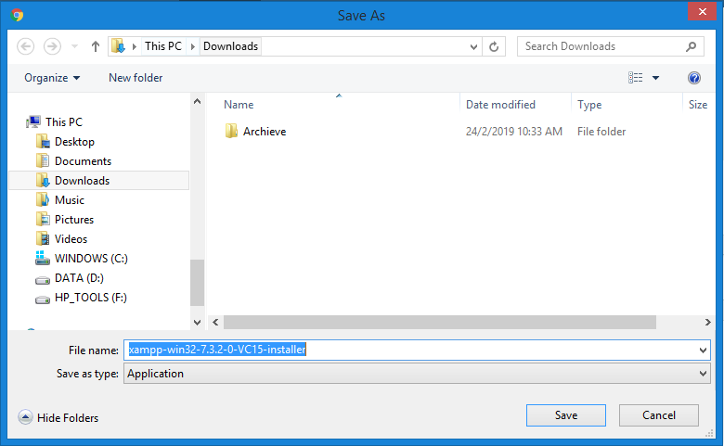

1. Run file xampp-win32-**[X.X.X-VCXX]**-installer.exe

Note: [X.X.X-VCXX] refers to the current version of the installer. It might differ with the version you see on the XAMPP website.

1. Click the Next button.

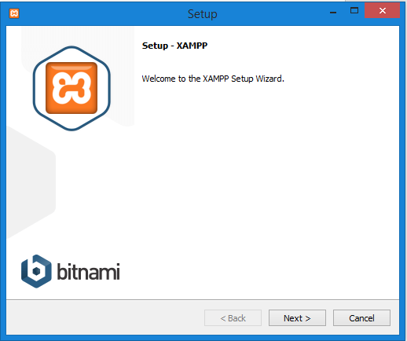

1. Please ensure you choose **Tomcat** and **MySQL**.

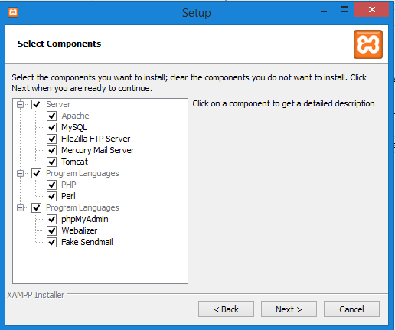

1. Choose a folder as C: \xampp and click the Next > button.

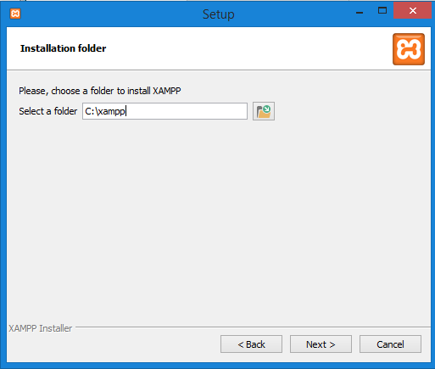

1. Untick “Learn more about Bitnami for XAMPP” and click Next button.

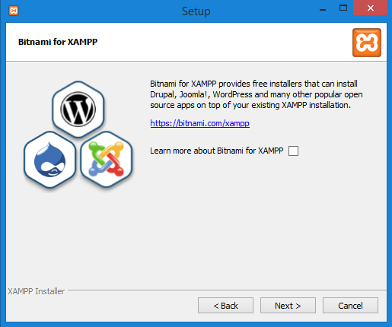

1. XAMPP is now ready to install.

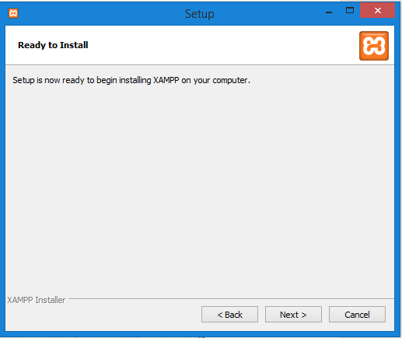

1. Wait for the installation process to complete.

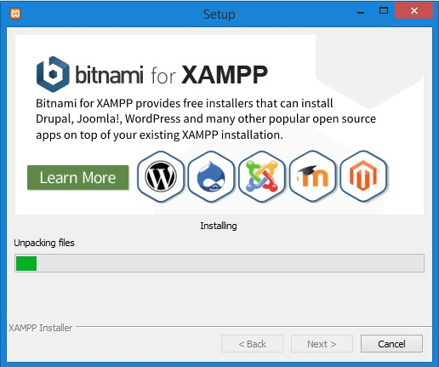

1. Click Finish button once completed and the Control Panel should start right after that.

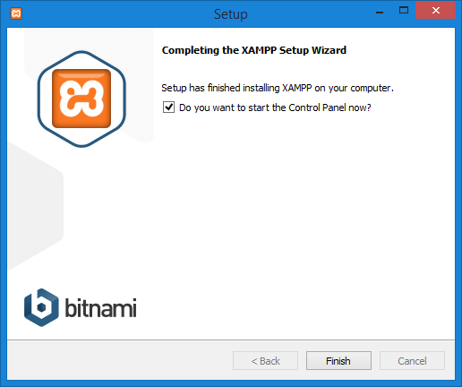

1. Only for first time launching, select English as the default language for XAMPP. Click the Save button.

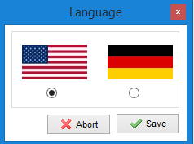

1. Click the Start button to launch **Apache, Tomcat** dan **MySQL** service.

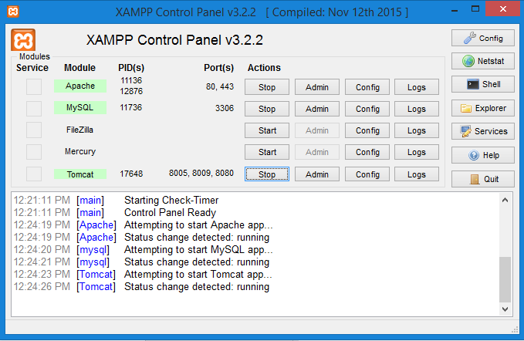

**Note:** Why do we need Apache? We will use phpmyadmin as a tool to manage our database in the upcoming tasks. You may use other tools such as MySQL Workbench, Netbeans Database Manager etc. Do not confuse with the functions of various instruments used during the JSP development. Try to understand the context of the usage of each of them.

# Reflection

What have you learnt from this exercise?

**Task 2: Change the Default Root Password of MySQL Database**

|  |  |
| --- | --- |
| **Objective:** | Change the root password of MySQL Database |
| **Problem Description:** | To reset a new root password for MySQL Database |
| **Estimated time:** | 5 minutes |

By default, the MySQL installation that ships with XAMPP have an empty root password. It is a severe security risk, especially if you plan to use XAMPP in production scenarios.

To change the MySQL root password, follow these steps:

* 1. Ensure that the MySQL server is running.
  2. Open your Windows command prompt by clicking the "Shell" button in the XAMPP control panel.

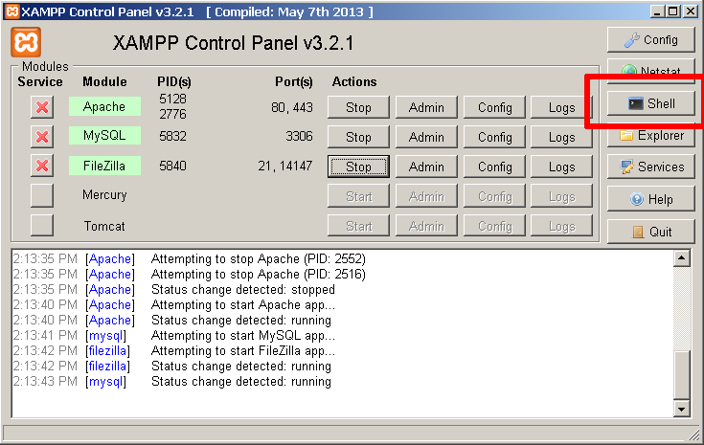

* 1. Use the mysqladmin command-line utility to alter the MySQL password, using the following syntax (Note: We will use “admin” as our password during the lesson):

mysqladmin --user=root password "admin"

* 1. To test that your password change has been accepted, by attempting to connect to the MySQL server using the MySQL command-line client in the same directory. For example, you could use the command below to connect to the server and return the results of a calculation:

mysql --user=root --password=admin -e "SELECT 1+1"

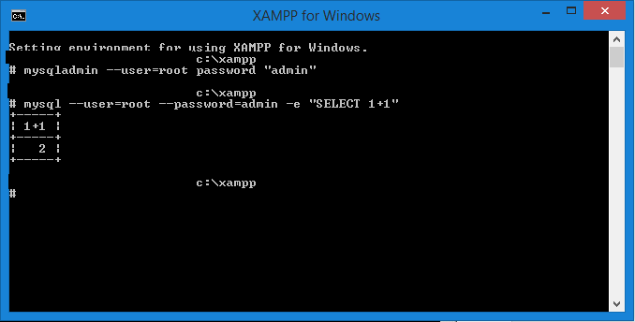

* 1. To update the password in the future, you can use the following syntax:

mysqladmin --user=root --password=oldpassword password "newpassword"

* 1. To test that your password change has been accepted, by attempting to connect to the MySQL server using the MySQL command-line client in the same directory. For example, you could use the command below to connect to the server and return the results of a calculation:

mysql --user=root --password=gue55me -e "SELECT 1+1

# IMPORTANT:

To avoid forgetting the password during our lesson, please set the MySQL password as ***admin*** ONLY..!

**Remark**: The above instructions are taken from Apache Friends Documentation. You may retrieve the documentation at <http://localhost/dashboard/docs/reset-mysql-password.html>after done with the XAMPP installation.

# Reflection

What have you learned from this exercise?

Troubleshooting Notes: Fixing phpMyAdmin Error

Did you get an error page when opening the phpMyAdmin?

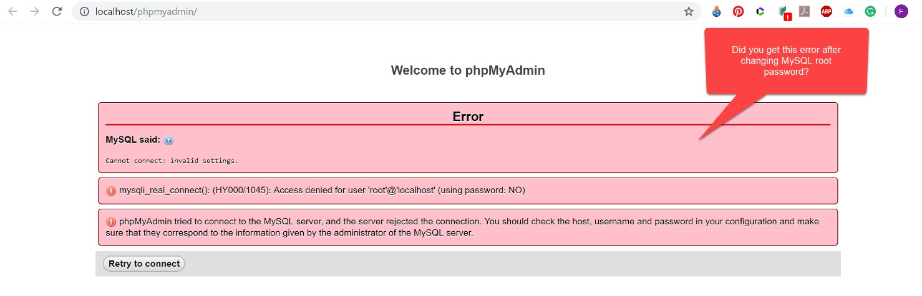

Follow these steps to fix it.

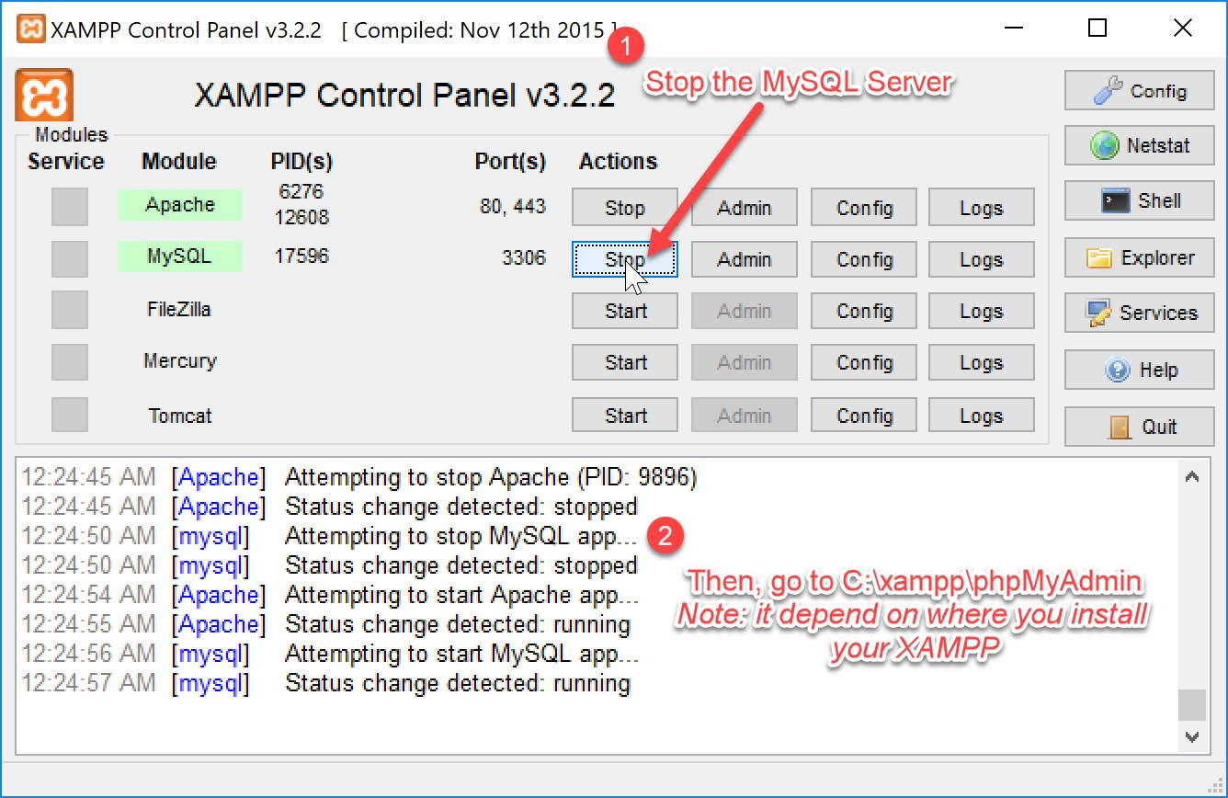

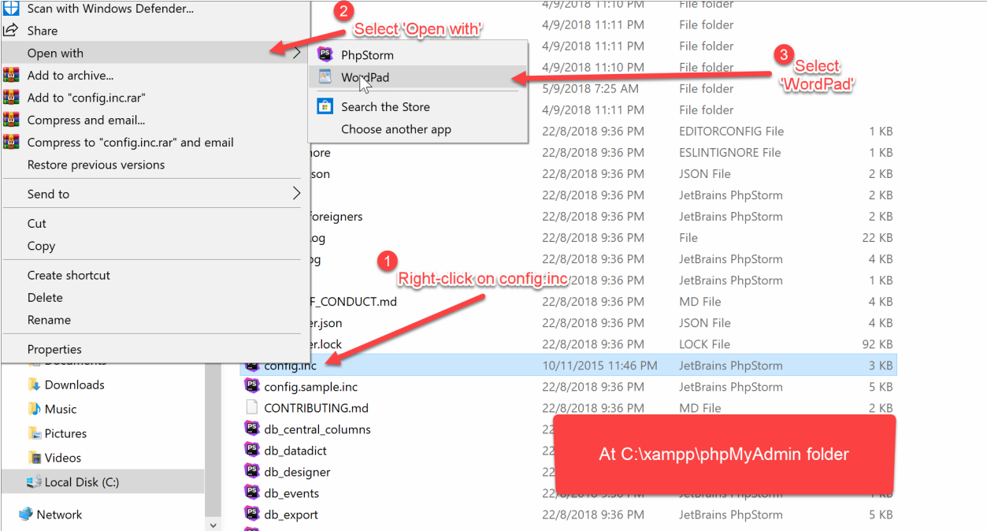

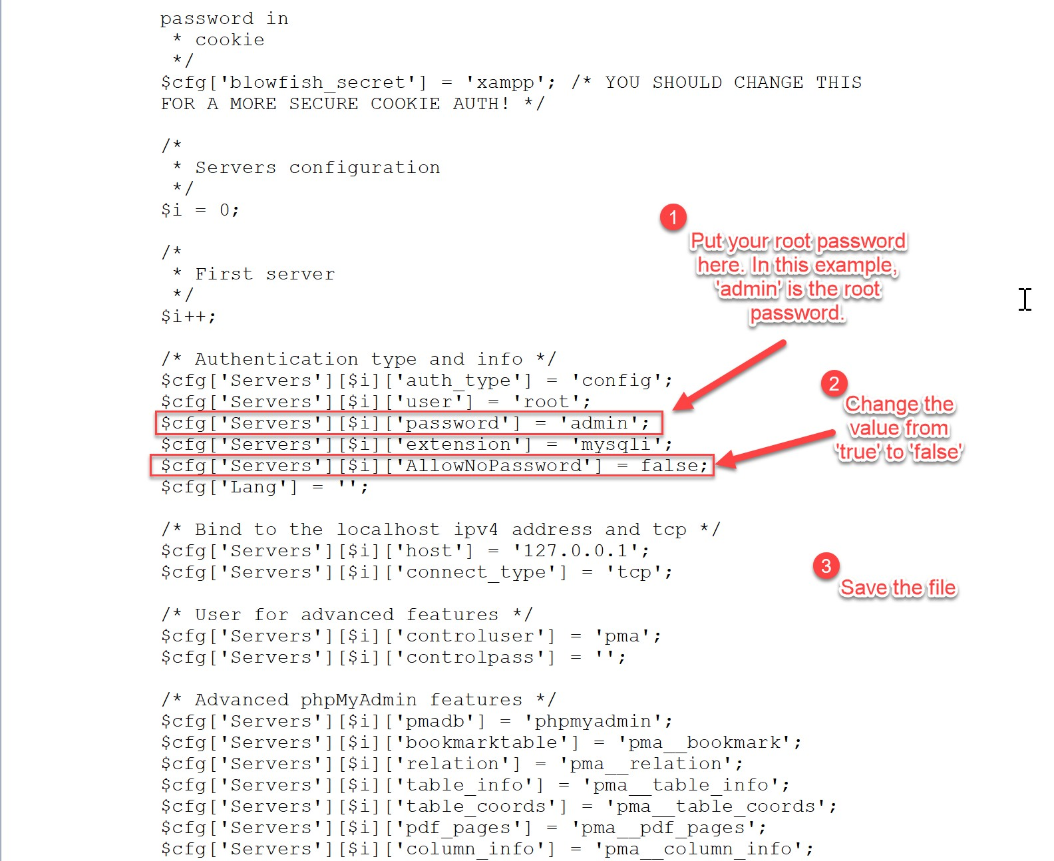

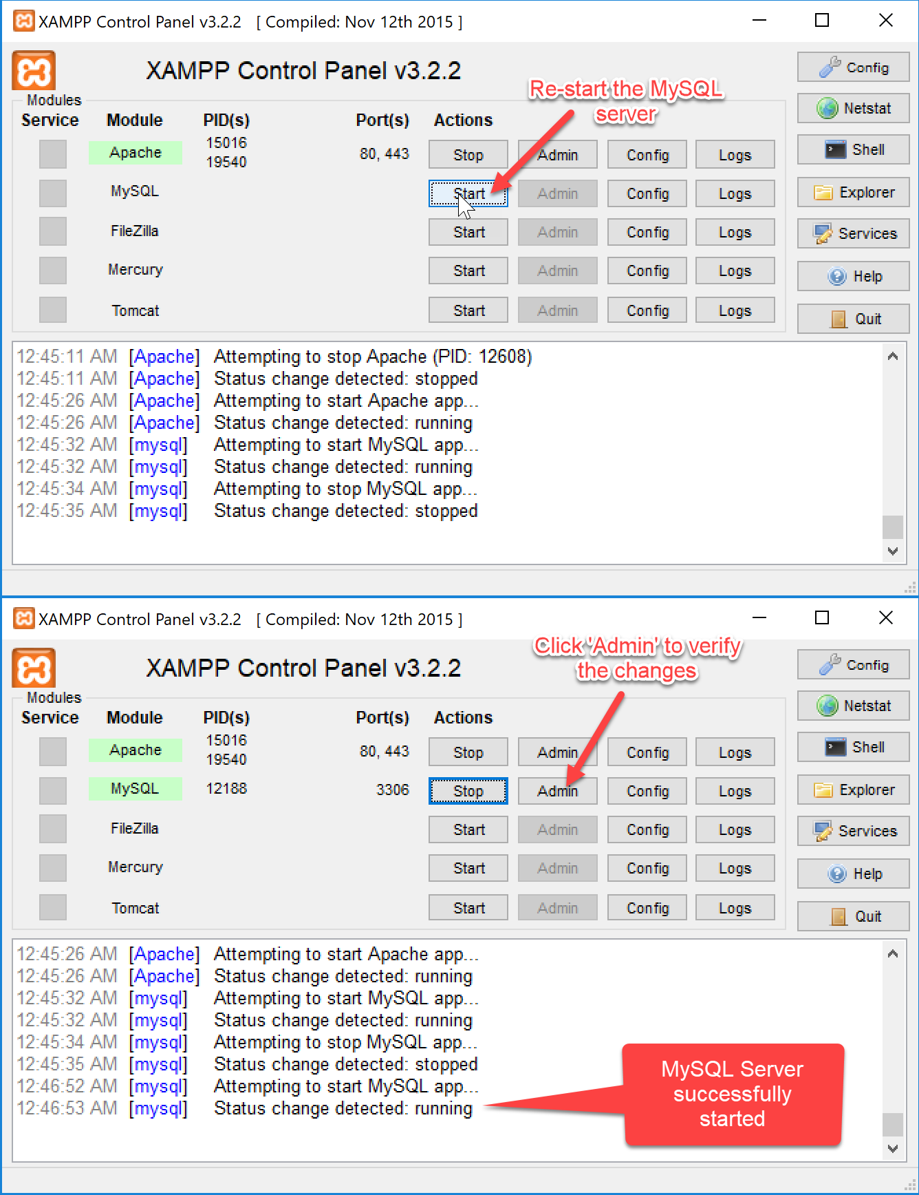

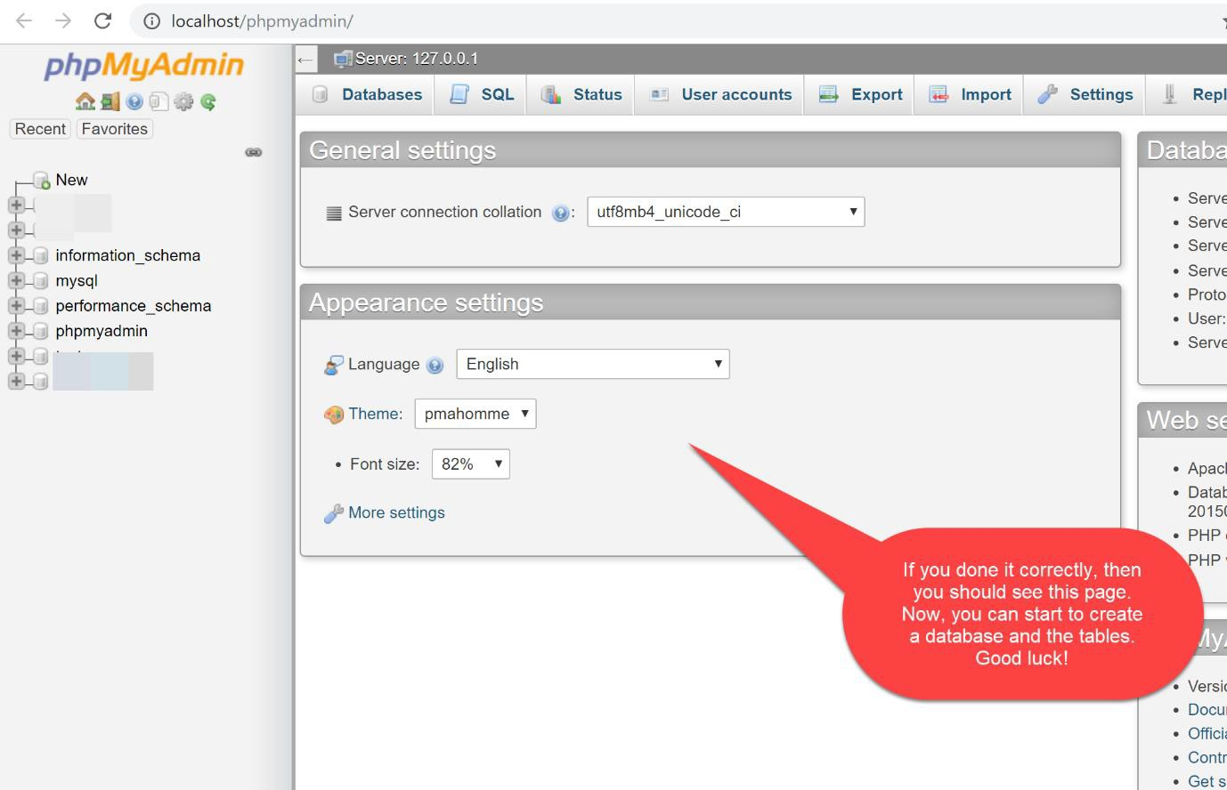

If you can’t edit or save the *config.inc,* follow the steps below:

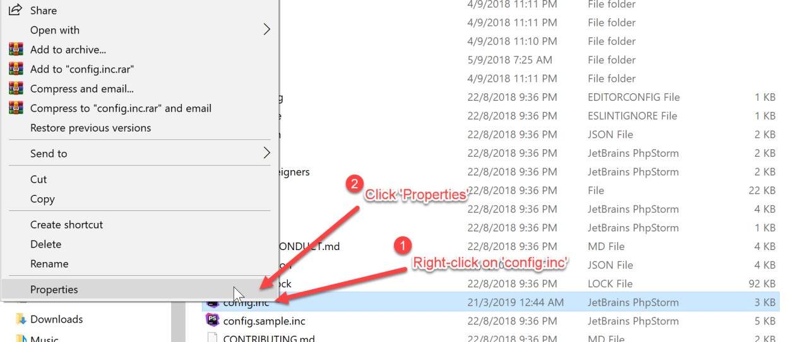

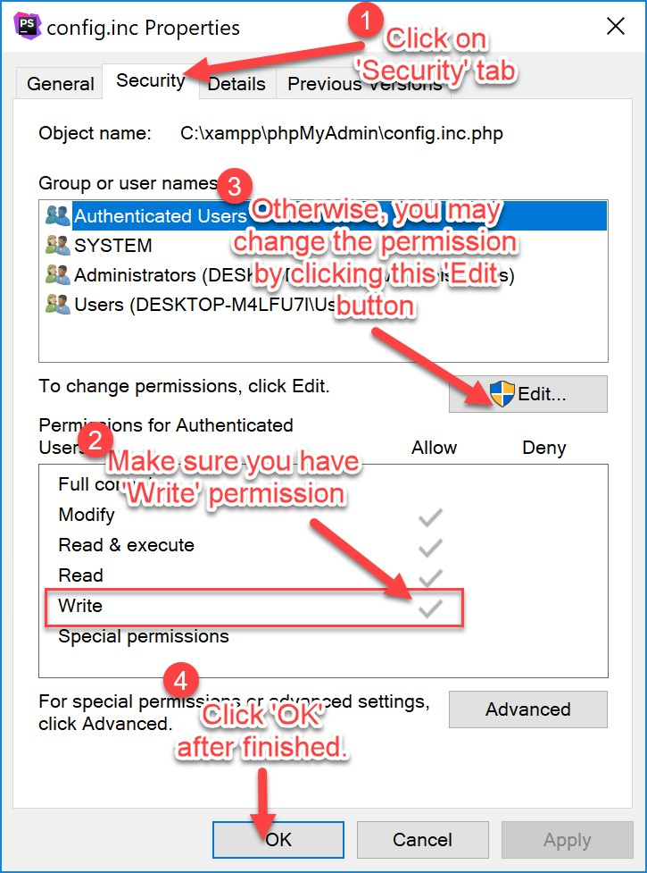

**Task 3: Managing Apache Tomcat**

|  |  |
| --- | --- |
| **Objective:** | Testing the access and add a new user to Apache Tomcat in XAMPP |
| **Problem Description:** | To configure user access for Apache Tomcat in XAMPP and test the access at localhost. |
| **Estimated time:** | 30 minutes |

In the previous task, we have successfully installed Apache Tomcat which is part of XAMPP software package.

* + 1. Make sure Apache Tomcat is running. You can see that status from XAMPP control panel.

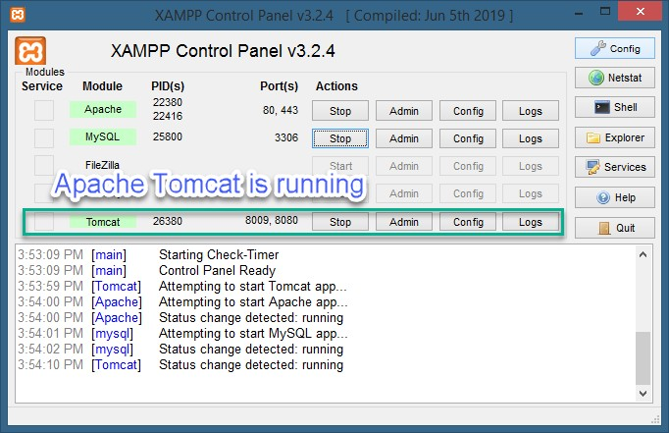

* + 1. Open the browser, and go to http://localhost:8080/. If Apache Tomcat is running correctly, you will see a homepage as follows:

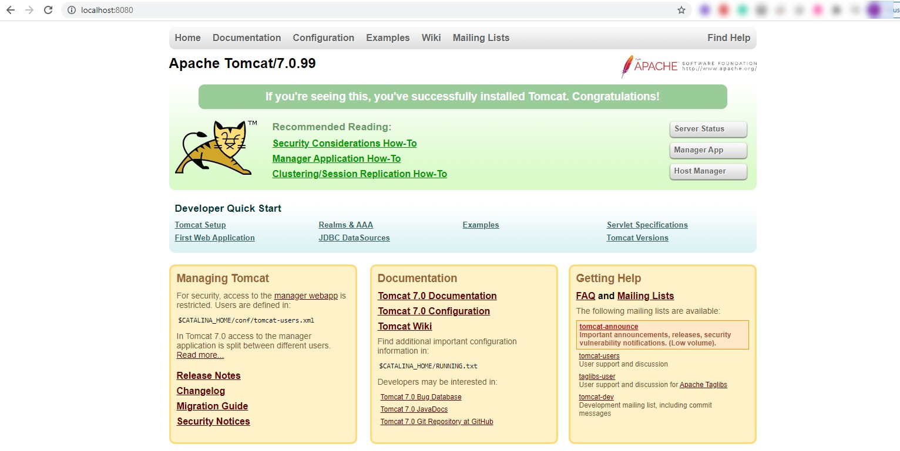

* + 1. Click on the “Manager App” of Apache Tomcat/7.0.99 homepage and there will appear a page ask for username and password. Do not panic, just click “Cancel”.

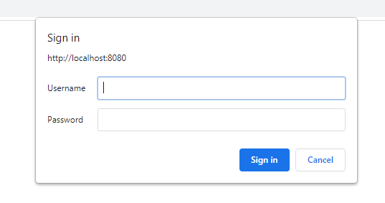

* + 1. As our Apache Tomcat currently does not has any defined user, a page below will be shown on the browser.

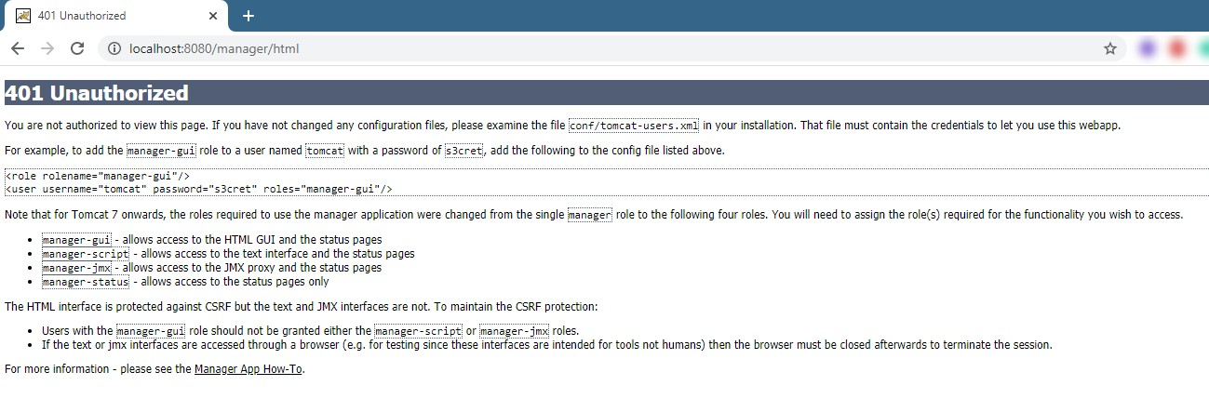

* + 1. To define a new user, click **Stop** Apache Tomcat server at the XAMPP Control Panel and click “Config” > tomcat-users.xml

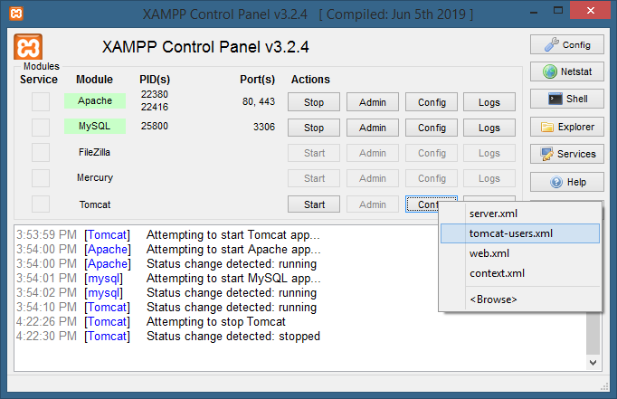

* + 1. The tomcat-users.xml will be opened using the default editor in your system. Scroll down the file until you see the </tomcat-users> tag. Add the tags below at the top of </tomcat-users> tag.

<role rolename="manager-script"/>

<role rolename="manager-gui"/>

<user username="admin" password="admin" roles="manager-script,manager-gui"/>

* + 1. Save the file. Finally, tomcat-users.xml will look like this

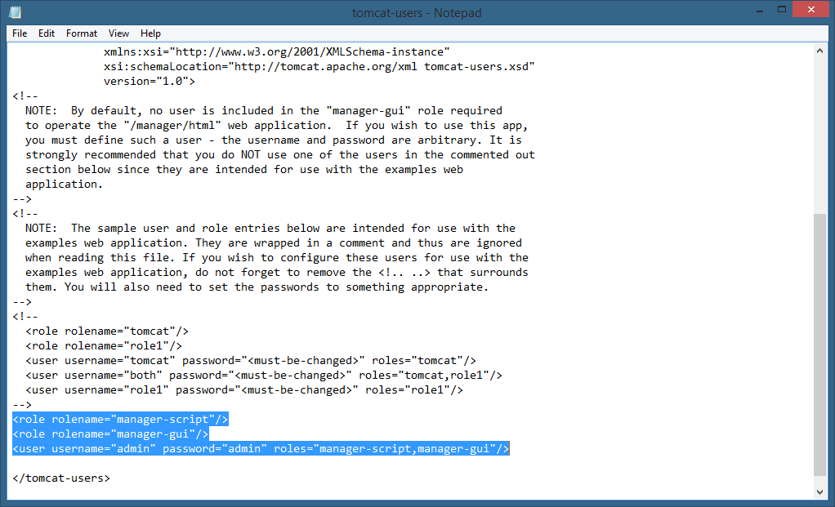

* + 1. We have added a new user “admin” with a password “admin”. Be sure to change the password when you deploy your application on a production server.
    2. Now, **start** the Apache Tomcat and repeat Step 2 and Step 3. This

time, put the username as “admin” and password as “admin”.

* + 1. If you did the above steps correctly, you will see the screen as below:

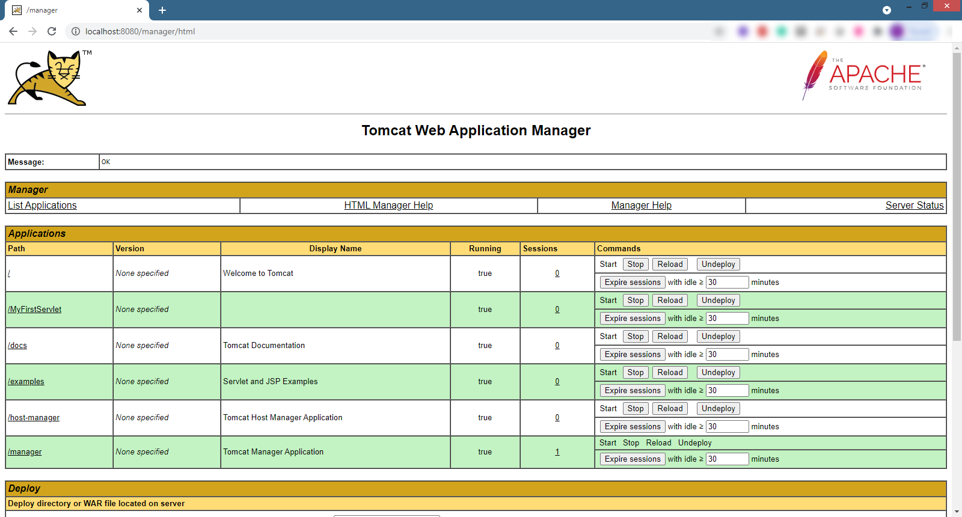

**Task 4: Netbeans 12.3 IDE Installation**

|  |  |
| --- | --- |
| **Objective:** | Netbeans 12.3 IDE Installation |
| **Problem Description:** | To setup a proper environment for Java Web Application development. |
| **Estimated time:** | 30 minutes |

To start the Netbeans 12.3 installation process, follow the steps below:

* + 1. Go to https://netbeans.apache.org/download/index.html
    2. Click “Download”. Choose the installer that appropriate with your operating system and computer architecture (x32 or x64). A correct installation program could be something like this *Apache-NetBeans- 12.3-bin-windows-x64.exe*

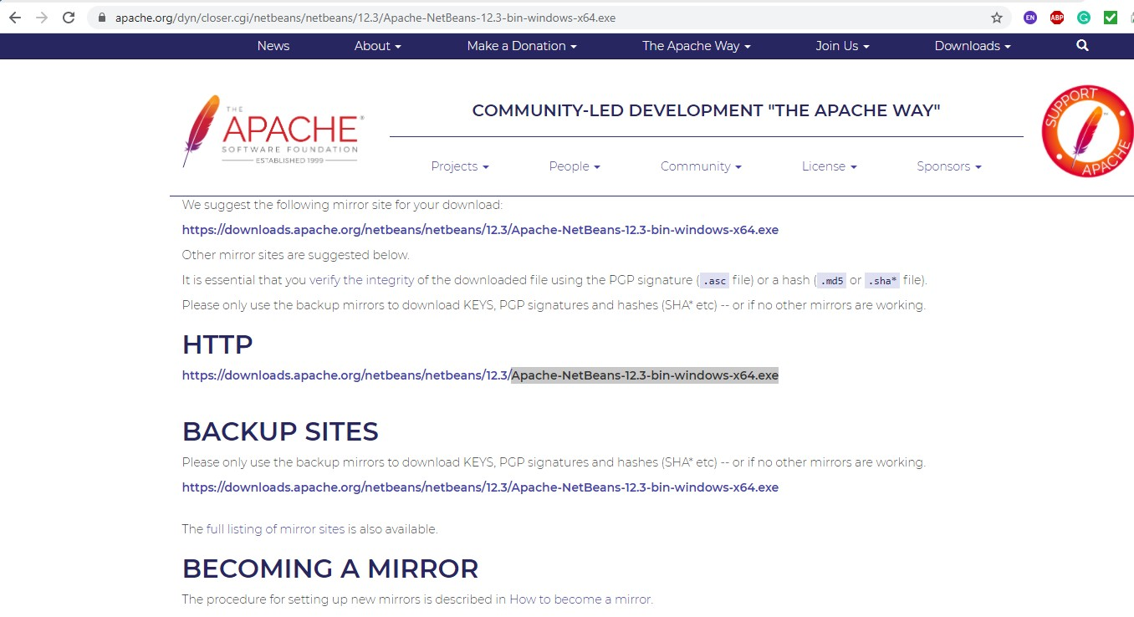

* + 1. After the download finish, double-click on the installer and click

“Next” until you reach the following screen:

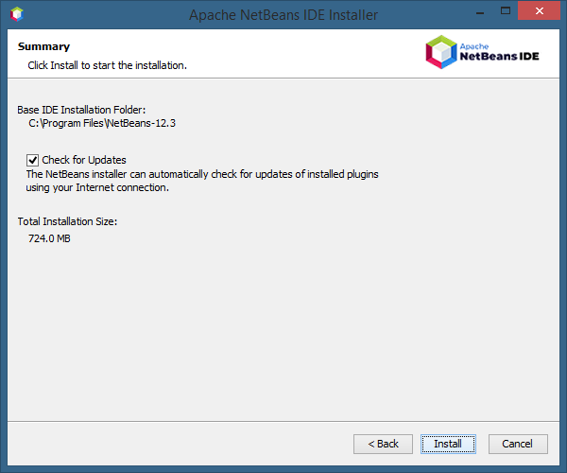

* + 1. Make sure you tick the “Check for Updates”, then click Install. Wait until the installation finish.
    2. Run the Netbeans. If you have previous installation, the pop-up windows as below may appear and simply click “Yes”. This will import your previous configuration to a new one.

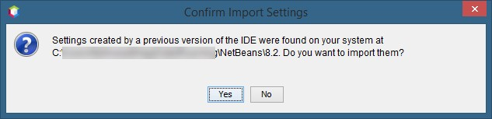

* + 1. Finally, you will get the following screen.

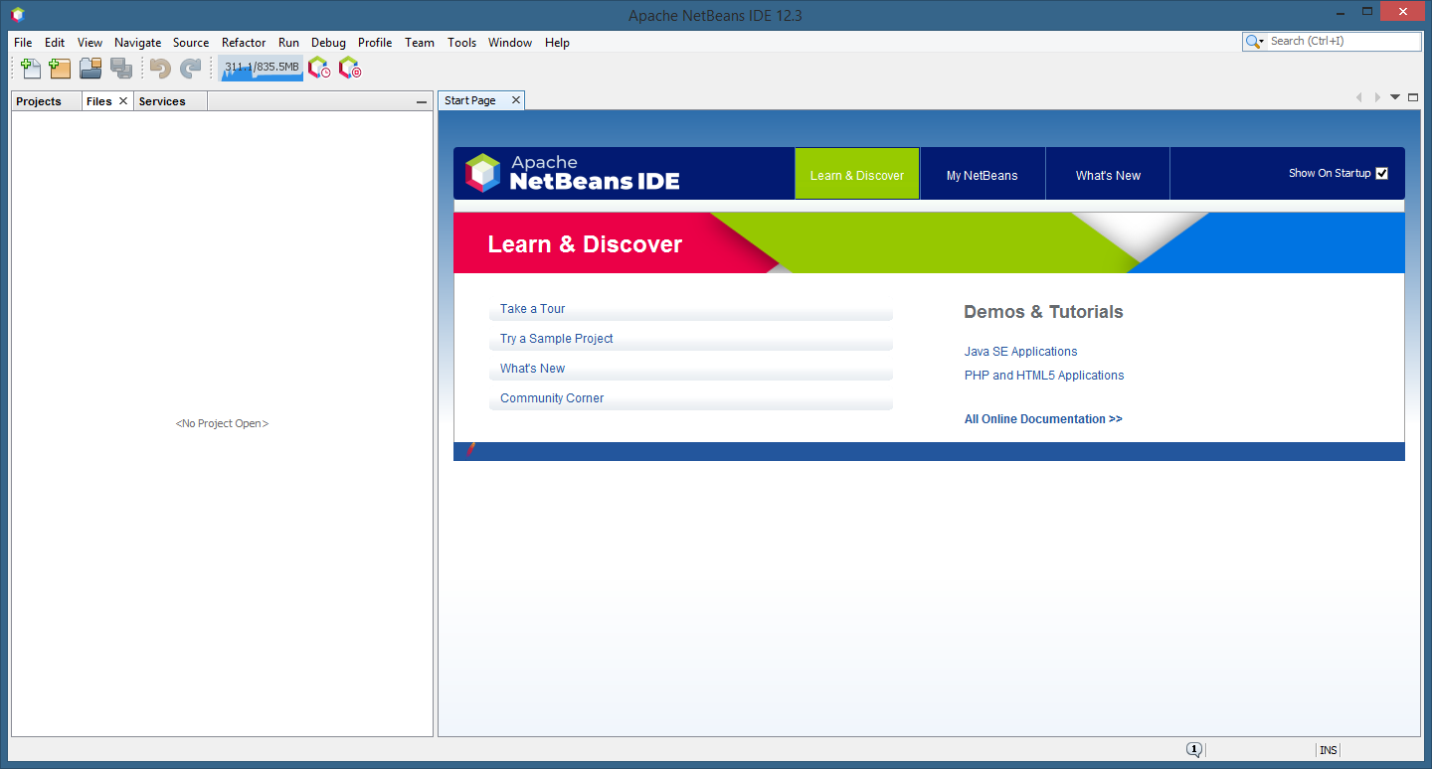

* + 1. Now, you are ready to start developing your first Java web application. Well done!

**Task 5: Linking Netbeans to Apache Tomcat and Writing a Simple Java Servlet**

|  |  |
| --- | --- |
| **Objective:** | Link Netbeans to Apache Tomcat and Writing a Simple Java Servlet |
| **Problem Description:** | To write a simple Java Servlet |
| **Estimated time:** | 15 minutes |

1. Create a directory *C:\[MATRICNUMBER]*.
2. Go to *C:\[MATRICNUMBER]* Lab’s directory and create sub-directory as *Lab 1*

*– Servlet*.

1. Open your NetBeans.
2. Go to File -> New Project

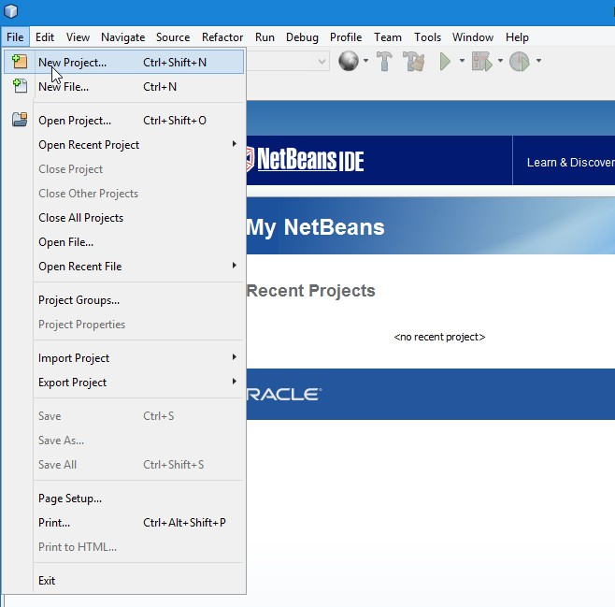

1. Select Java with Ant -> Java Web -> Web Application and click Next.

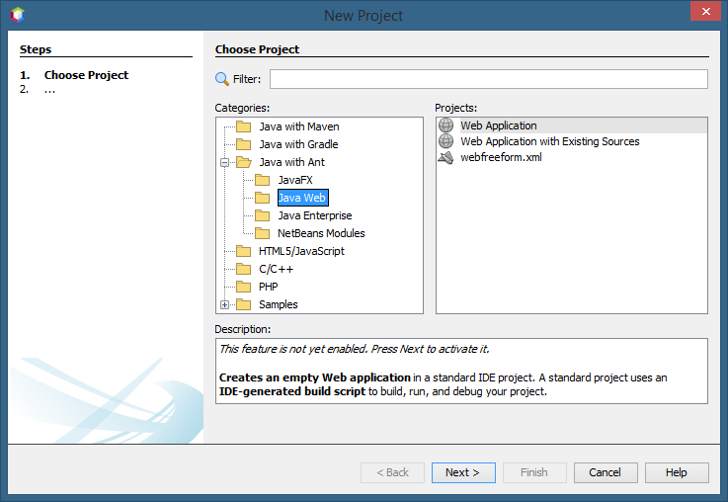

1. Type Project Name: *MyFirstServlet*.
2. Click Browse and choose Project Location: *C:\[MATRICNUMBER]\Lab 1 - Servlet*. Then click the Next button.

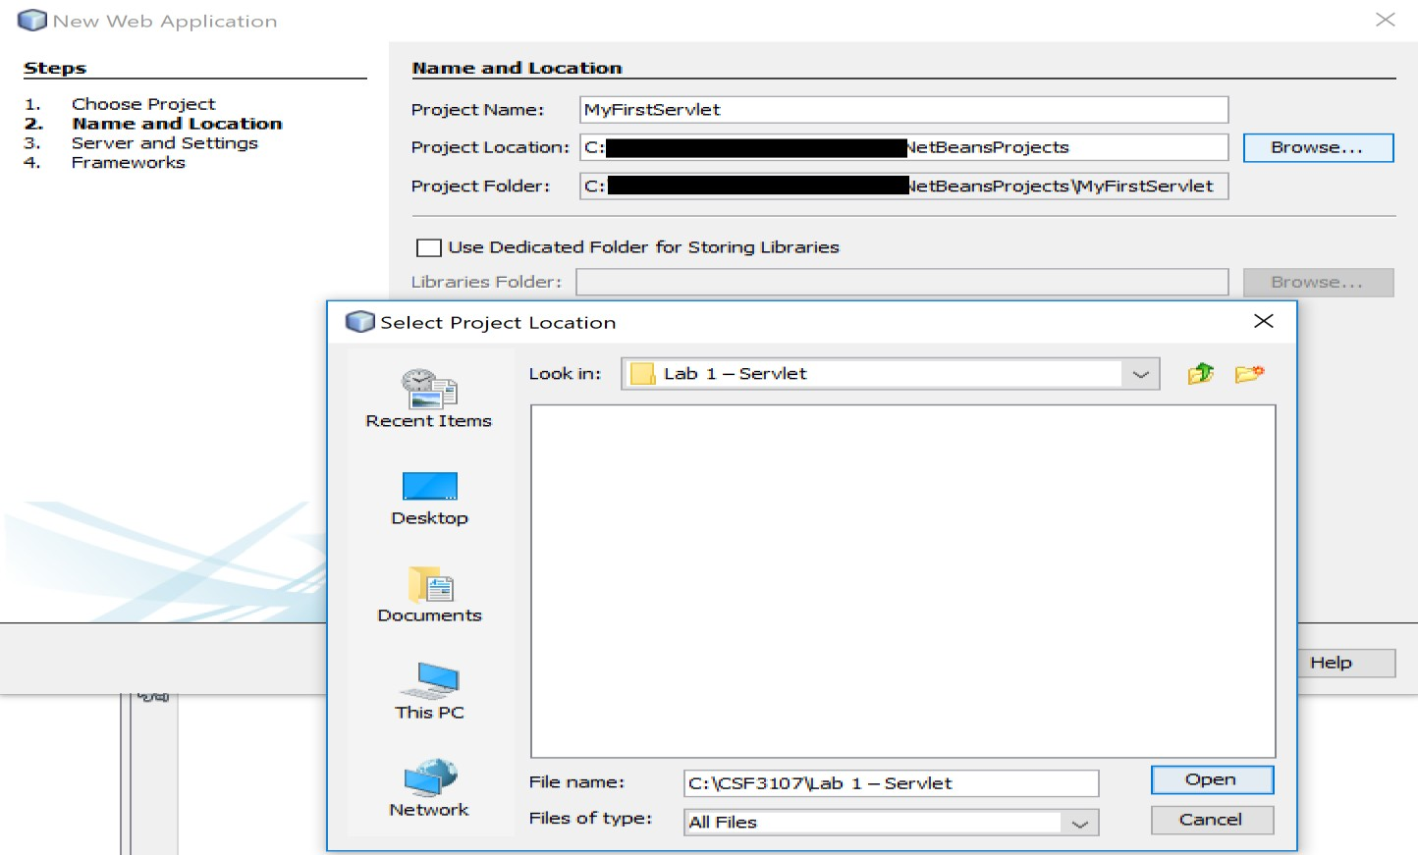

1. Before we can run our Java Web Application, we need to link it to Apache Tomcat Server. Follow the diagrams below to link Netbeans with Apache Tomcat in XAMPP.

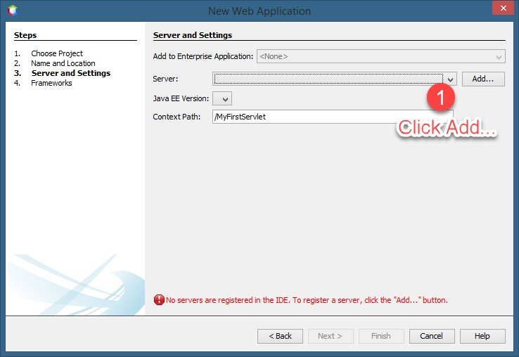

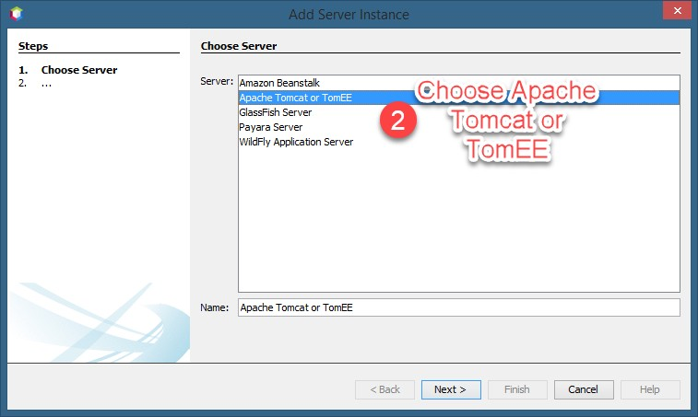

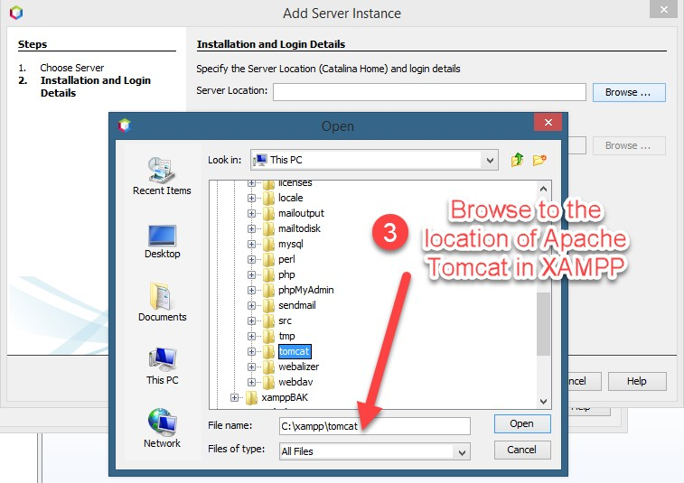

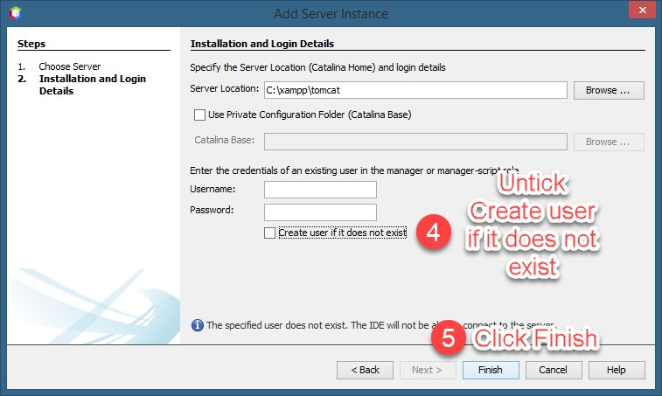

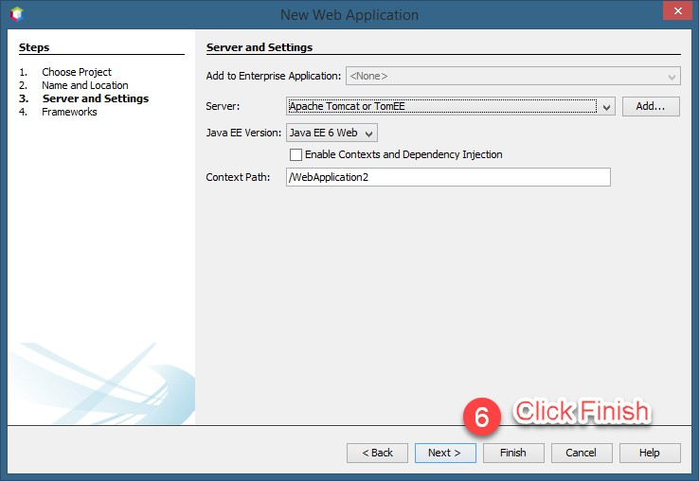

**Note:** the above steps only need to be ran for the first time you link the Netbeans to Apache Tomcat in XAMPP. After this, you just need to select it from the screen.

1. If everything okay, you will see the following screen:

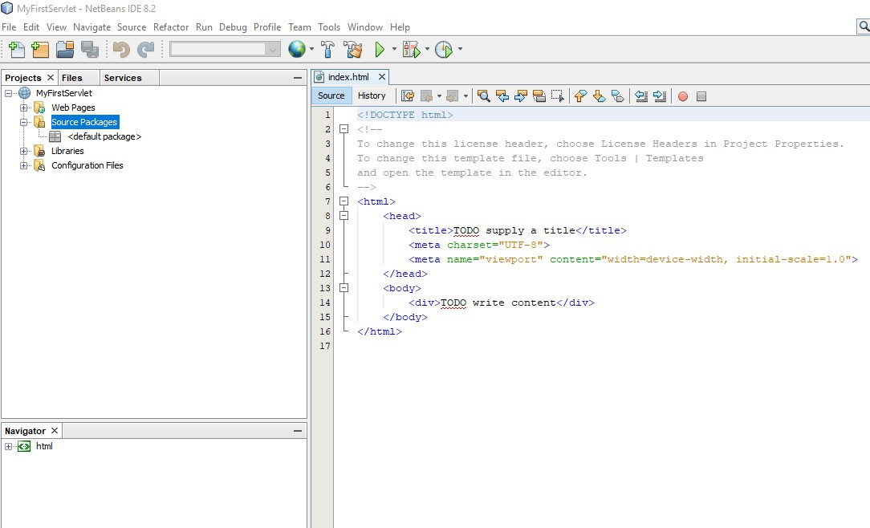

1. Create a new Servlet file.

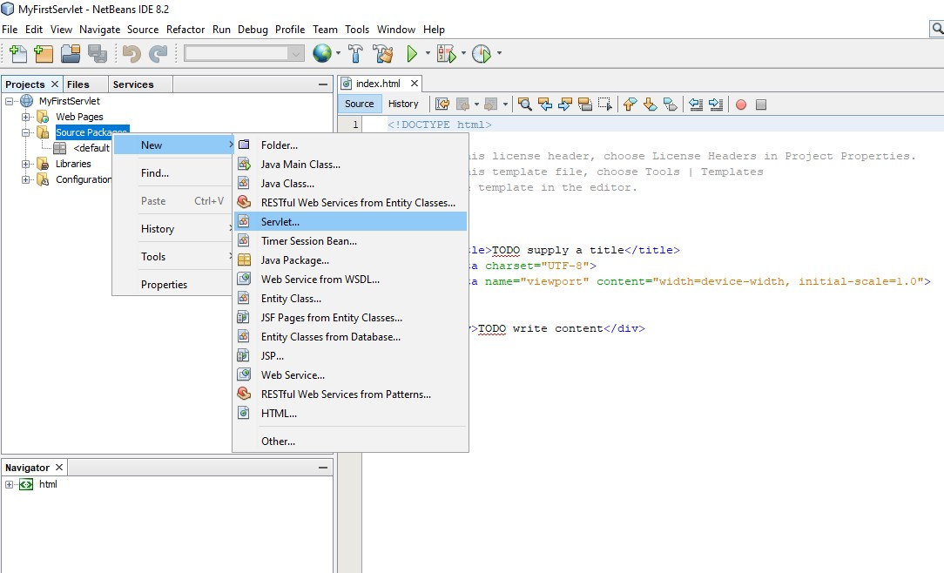

1. Name your servlet as *HelloServlet*.

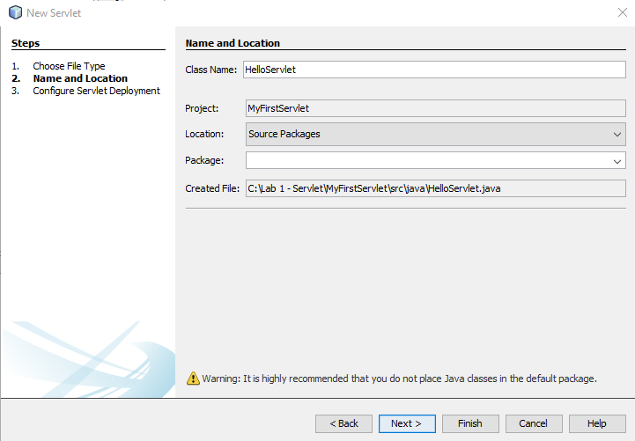

1. Tick the “Add information to deployment descriptor (web.xml)”

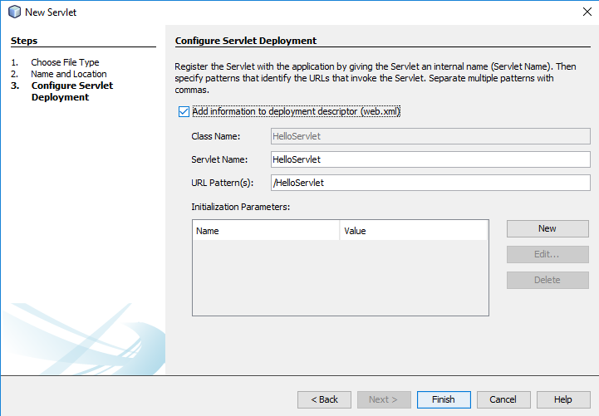

1. NetBeans has produced a new file named *HelloServlet.java*. You may see the location of it on the left side of NetBeans editor. On the right, are the servlet codes generated by NetBeans.

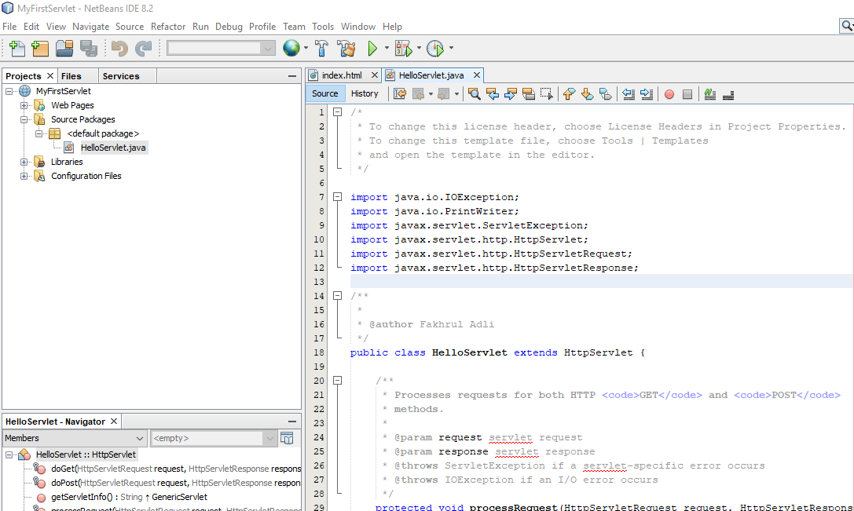

1. Browse through the servlet file until you find the processRequest() method.

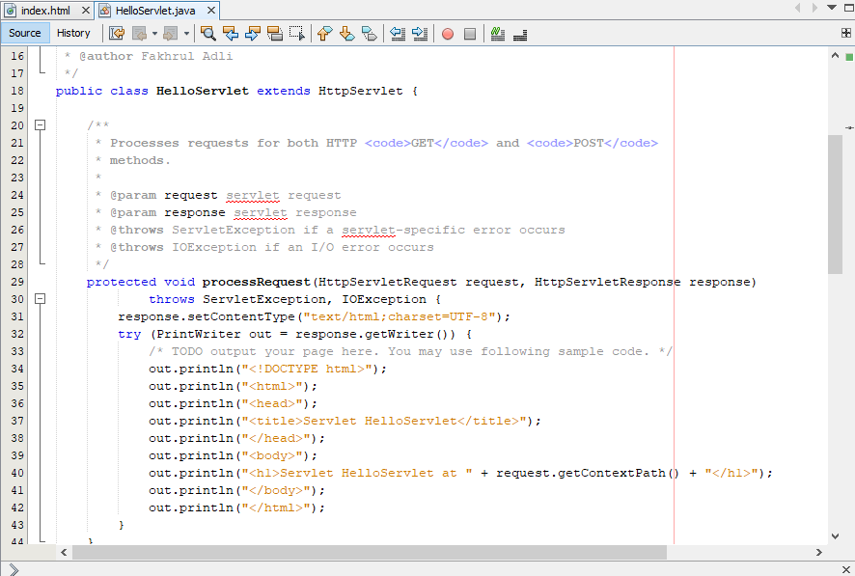

1. We are going to make a simple modification to the existing codes. Modify the them as follows. Refer to line 37, 40 and 41.

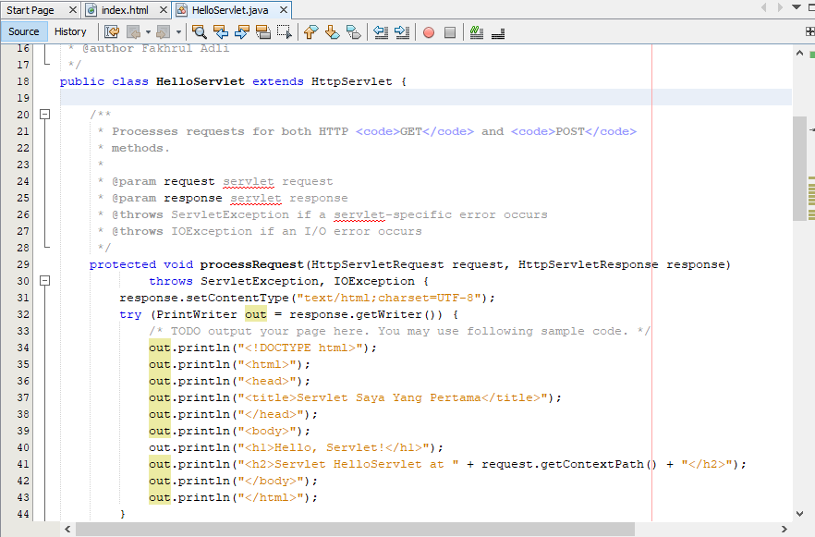

1. After finished your modification on the previous step, run *HelloServlet.java* by right-clicking on it and select *Run File*.

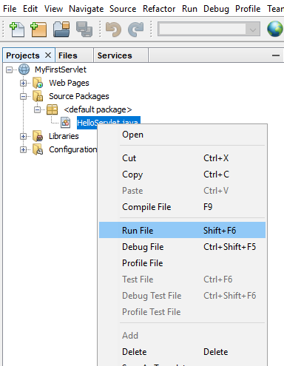

1. Before you can see the output, a dialogue box will appear. This dialogue box allows us to add some request parameter. At this moment, we will not supply any parameter. Just click OK button.

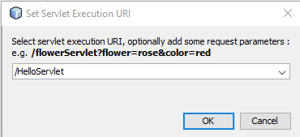

1. You will see the following output on your browser.

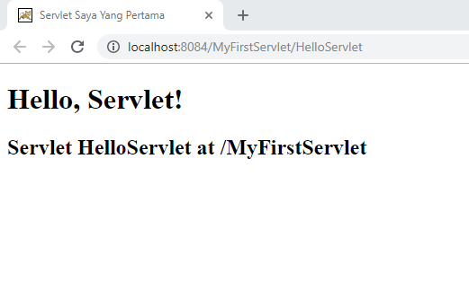

1. Now, we will make further modification to our servlet file. This time, we are going to modify the *doGet()* method. Browse through the codes in *HelloServlet.java* until you find the desired method. Type the codes as provided in the screenshot below. Read the comments carefully and try to understand what each of the codes does. **Remark: Please remove processRequest() method from the body of *doGet()* method.**

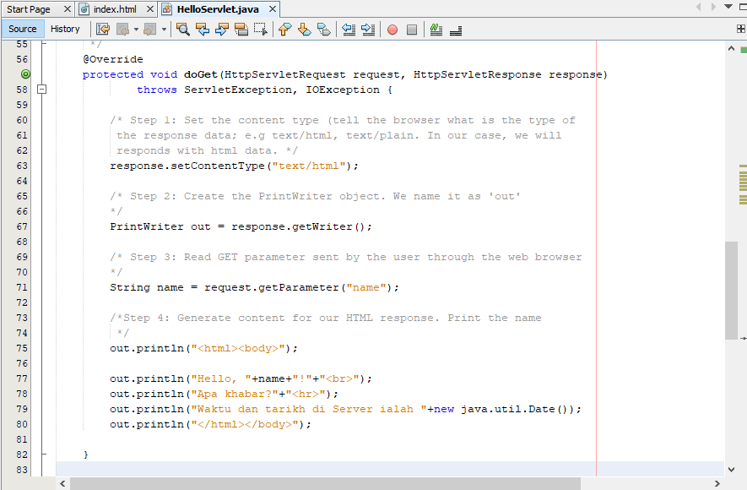

1. After finish, right click on *HelloServlet.java* and click Run. As you have seen previously, a dialogue box shows. This time, we will supply a value *Bob* to the parameter *name*. Then, click the OK button.

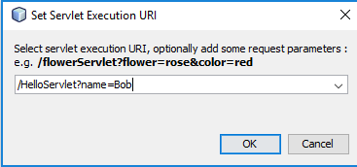

1. If everything goes well, you will see the output as below:

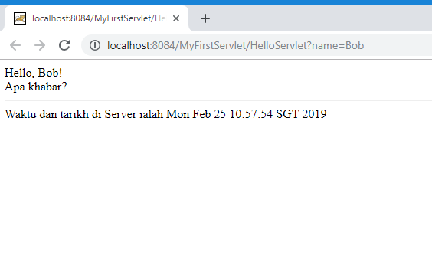

1. Rerun **step 20** again, this time do not supply any request parameter. What do you see from the output? Do you see something like the following screenshot? How to avoid the *null* from being displayed?

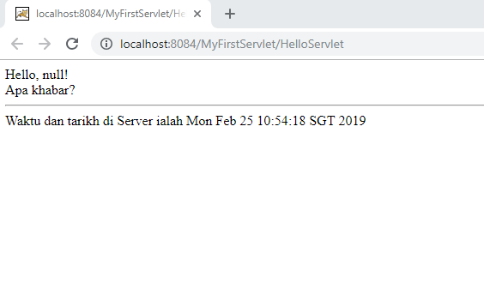

1. You can upgrade your code in HelloServlet.java by putting the following codes into it. By doing this, if no value supplied to the parameter *name*, the request will be passed to *processRequest()* method, and this will avoid from the *null* value appears on the browser.

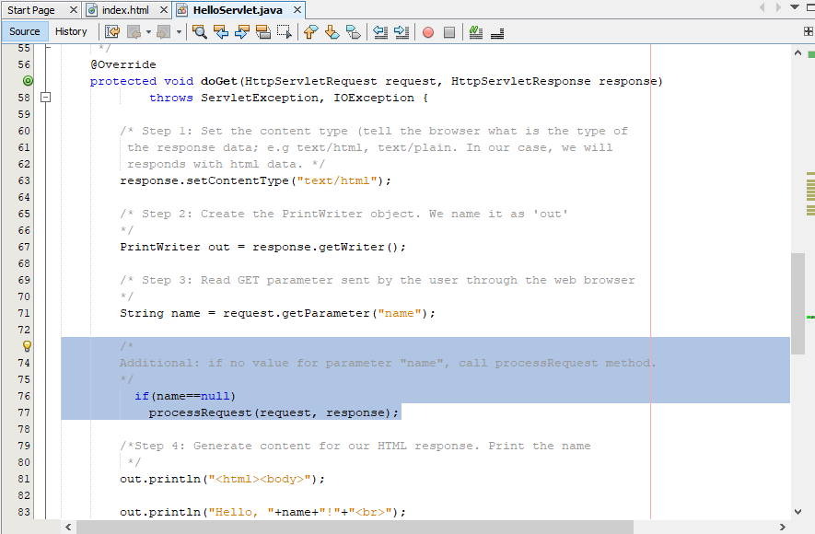

1. So, if you rerun the file and without supplying any parameter, you will see the output as follows:



It is the same output as can be seen in **Step 18**: why?

**Task 6: Writing a Simple JSP Program**

**Objective**

**Problem Description**

**:** Writing a simple plain JSP program

**:**

Write a simple plain JSP program to display

“Welcome to [MATRICNUMBER]..!”

**Estimated time :** 15 minutes

* 1. Create a directory C:\[MatricNumber] Lab
  2. Go to C:\ [MatricNumber] Lab’s directory and create sub-directory as Lab 1 - JSP.
  3. Open your NetBeans.
  4. Go to File -> New Project
  5. Select Select Java with Ant -> Java Web -> Web Application and click Next.



* 1. Click the Next button.
  2. Type Project Name: *Lab1*.
  3. Choose Project Location: *C:\[MATRICNUMBER]\Lab 1*.

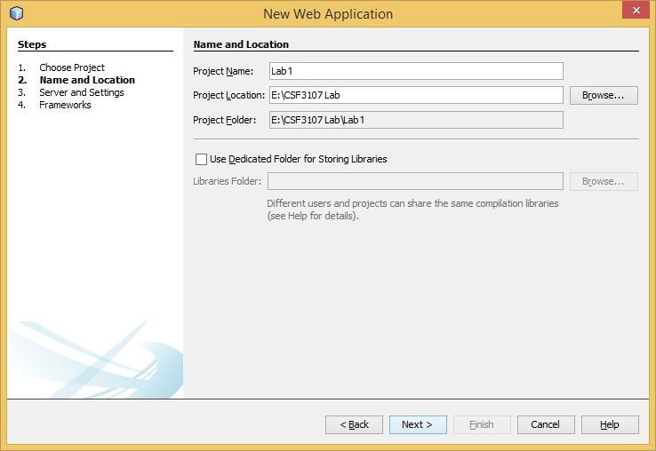

* 1. Click the *Next* button.
  2. Select Server: *Apache Tomcat or TomEE*
  3. Select Java EE Version: Java EE 6 Web.
  4. Click the Next button.

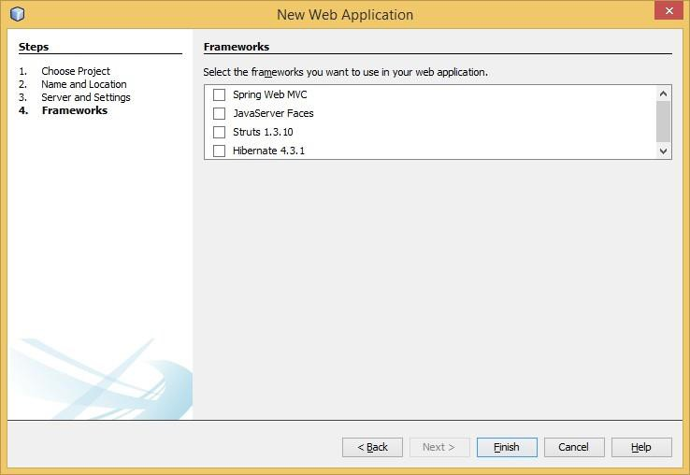

* 1. Click the Finish button.
  2. Create a new JSP’s file.

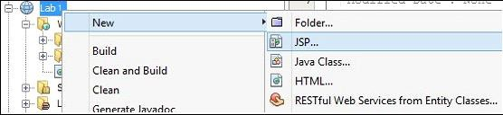

* 1. Type file name as *Welcome.*

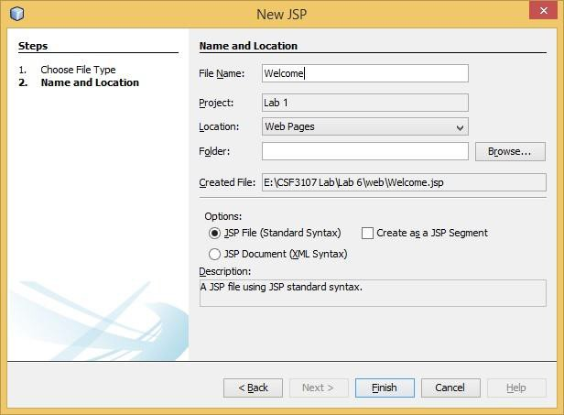

* 1. Click the *Finish* button.
  2. Type title as *[MATRICNUMBER] – Web Programming 2*
  3. Type header1 as *Welcome to [MATRICNUMBER]…!*.

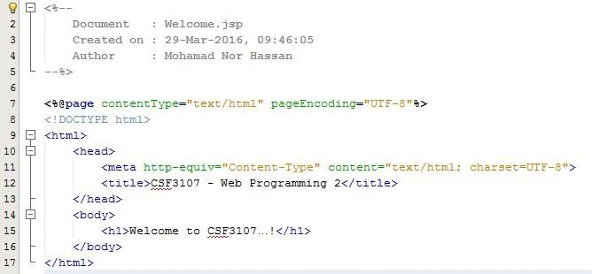

* 1. Click *SaveAll* icon



* 1. Right-click file *Welcome.jsp* and click *Compile File* (F9).

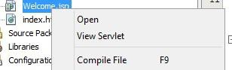

* 1. You will get notification message the bottom of Netbeans IDE with the green colour.

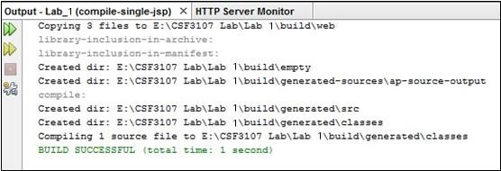

**Note:** Before running any JSP’s files for the first time upon opening your Netbeans IDE, you need to start your web server (i.e., Apache Tomcat). **Note**: Avoid these steps if Apache Tomcat already starts.

1. Go *to the Project*’s tab. Then right click *Welcome.jsp* file and click *Run File* (Shift+F6).

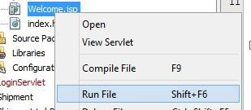

1. The output will appear in a web browser.

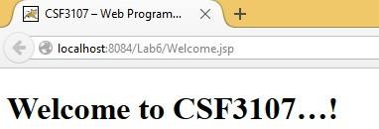

***Note:*** Beside using XAMPP to start or stop the Apache Tomcat, you may also do it directly from Netbeans as shown in the figure below.

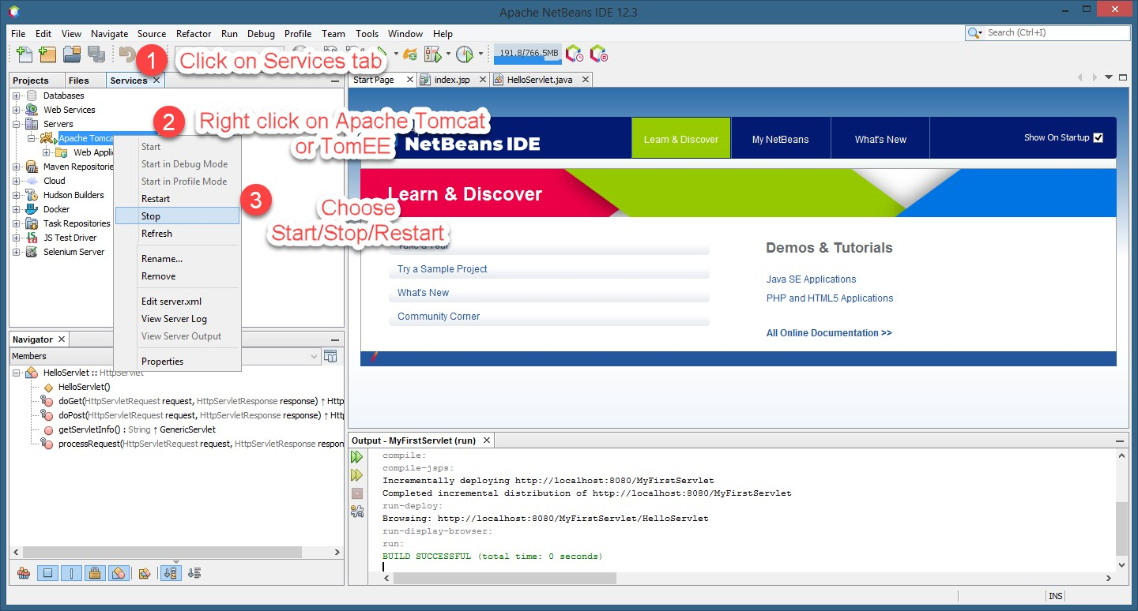

# Reflection

1. What have you learned from this exercise?
2. Explain the general concept of how the JSP’s file work?
3. Based on your observation of the previous tasks (Task 3 and Task 4), what are the differences you can find between servlet and JSP?

**Task 7: Use Java Reference Datatype/Class Wrapper in JSP**

**Objective**

**:** Using Java’s object in JSP page.

**Problem**

**Description**

**:** Display the current date, perform auto refresh header in

JSP’s page.

**Estimated time**

**:** 20 minutes

* 1. Go to project *Lab1*.
  2. Create a new JSP’s file as *useJavaObject*.

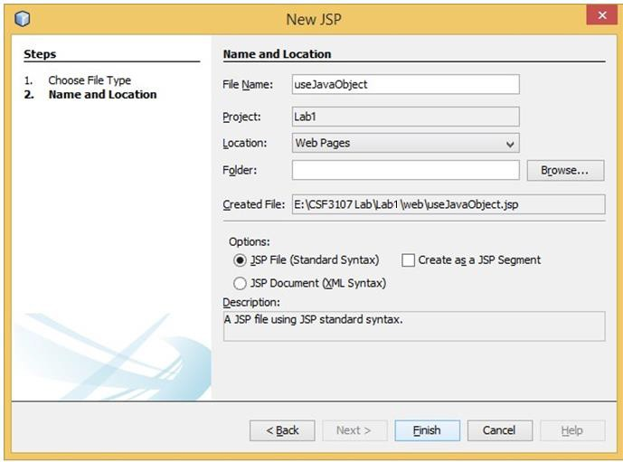

* 1. Click the *Finish* button.
  2. Change the title *Using Java’s object in JSP page*.
  3. Change the <h1> as *Display Current Date and* perform auto refresh header*.*
  4. Add *Java util* package for Date reference.

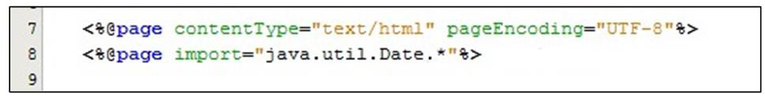

* 1. Write a Java Scriplet to create Date’s object and display the current date and time.

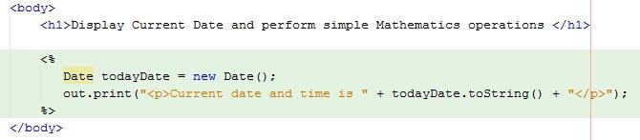

* 1. Continue writing a code to perform auto refresh header.

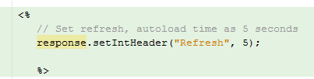

* 1. Save your file.
  2. Right-click *useJavaObject.jsp* and compile the program.

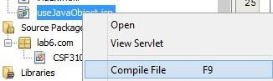

* 1. Finally, right-click *useJavaObject.jsp* and choose Run File to run the program.

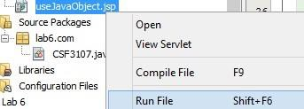

* 1. Review the output display in the browser.

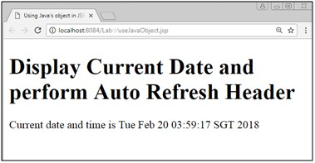

# Reflection

1. What have you learnt from this exercise?
2. What is Java Scriplet?
3. How to use Java code in your JSP’s page?

**Task 8: Using JSP Implicit object in JSP page**

**Objective**

**:** Using JSP Implicit object (Session) in JSP page.

**Problem**

**Description**

**:** Using Session object, perform simple Mathematics

operations in JSP’s page.

**Estimated time**

**:** 30 minutes

* 1. Go to Project *Lab1*.
  2. To create a JSP’s page, right click *Lab1-> New -> JSP*.

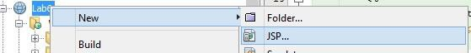

* 1. Create a new JSP’s file as *AttributeIsSet*.

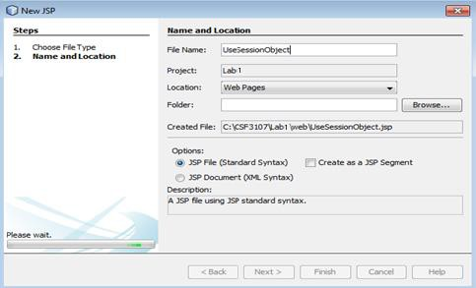

* 1. Click the *Finish* button.
  2. Source code for *AttributeIsSet*.*jsp* will appear.
  3. Write the code below:

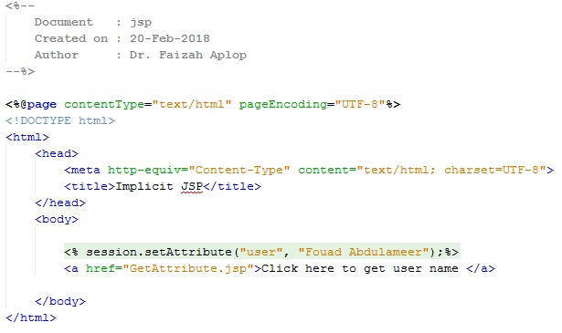

1. Save and compile *AttributeIsSet.jsp* file.
2. Run the *AttributeIsSet*.*jsp* file, and you should get the interface as below:

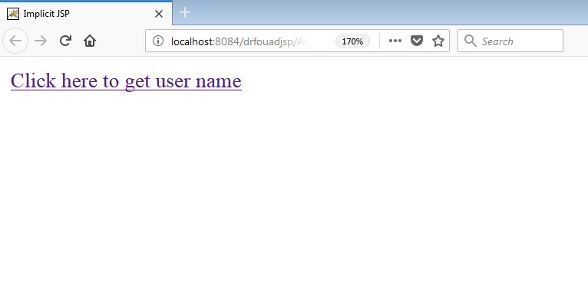

1. Repeat step 1 and step 2.
2. Key-in File Name: *GetAttribute*.
3. Click the *Finish* button.
4. Source code for *GetAttribute.jsp* will appear.
5. Write the *GetAttribute* code.

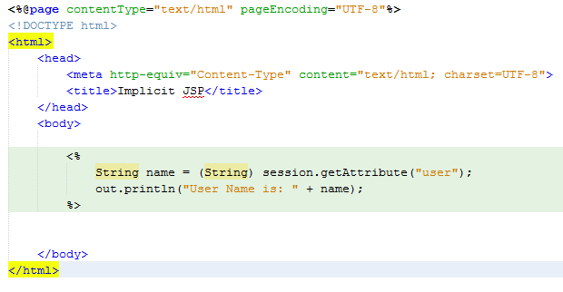

1. Compile *GetAttribute*.*jsp* file.
2. Run the *AttributeIsSet*.*jsp* file and click on the link.
3. Add math package to perform simple Mathematics operation in your page.



1. Create a new JSP’s file as *MathematicsOperations* to perform addition, multiplication and find the square roots of the number.

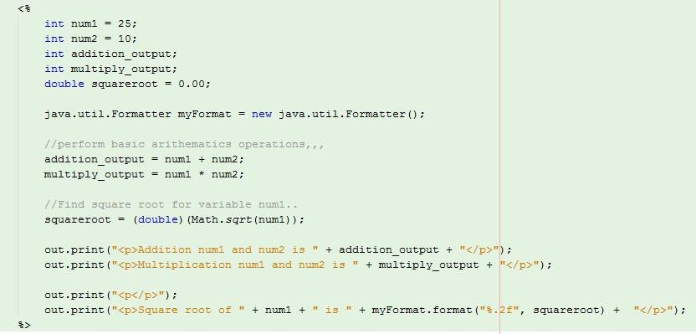

1. You should get the interface as below:

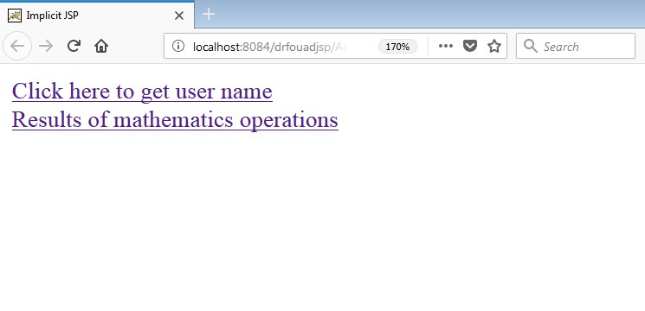

1. Review the outputs display in the browser.

# Reflection

1. How do you want to submit specific information from one form to next form?
2. What happened if the field name you specify in *request.getParameter (“field_name”)* in the second page is different from the field name you defined in the first page?

**Task 9: Populate Array values into HTML*’*s Table**

**Objective**

**:** Read Java array and populate it into HTML’s table.

**Problem**

**Description**

**:** i. Create a 2D array that store sales data.

ii. Then, read an array and populate into HTML’s table.

**Estimated time**

**:** 50 minutes

* 1. Go to Project *Lab1*.
  2. To create a JSP’s page, right click *Lab1 -> New -> JSP*.
  3. Key-in File Name: *populateArray*.

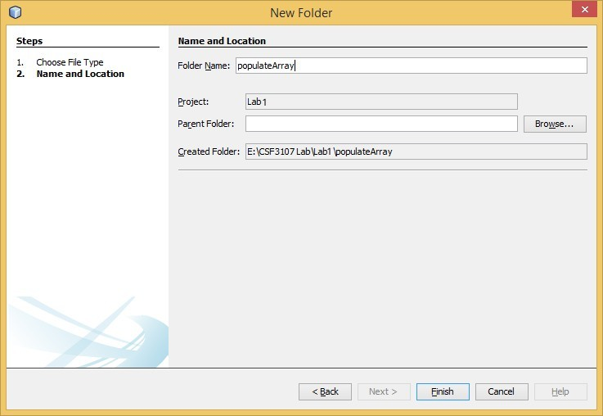

* 1. Click the *Finish* button.
  2. Prepare standard HTML’a markup for page *populateArray.jsp*.
  3. Write a Java Scriplet and store the following information into an array;

|  |  |  |  |
| --- | --- | --- | --- |
|  | Jan | Feb | Mac |
| Salesman 1 | 2500 | 2100 | 2200 |
| Salesman 2 | 2000 | 1900 | 2400 |
| Salesman 3 | 1800 | 2200 | 2450 |

* 1. Read the array and populate its value into HTML’s table.
  2. Save and compile *populateArray.jsp* file.
  3. Run the *populateArray.jsp* file and sample of output shows as below:

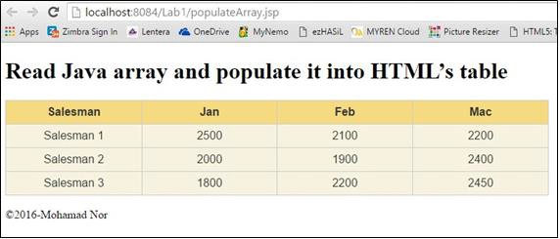

# Reflection

1. Write a sample syntax to declare 2D Java array.
2. Define a sequence of steps on how you accomplish Task 7.
3. What is the difference between HTML’s page and JSP’s page?

# Exercise

1. The following program is developed using Java Standard Edition.

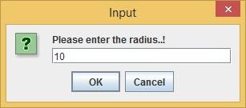

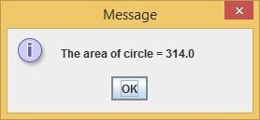

Convert this program into Web-Based application where the user can dynamically key-in radius and submit the request to get the area of a circle. You must ensure to accept only number as a radius.

1. Prepare the following file in the Notepad and save it as *Sales.csv*.

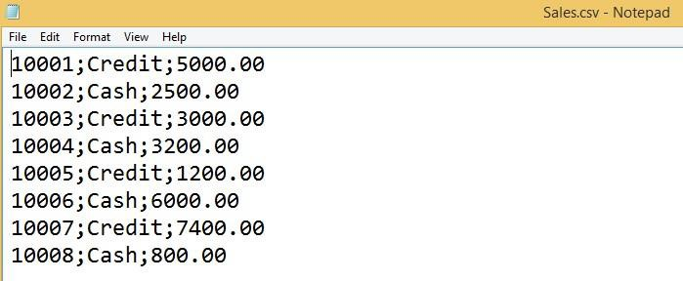

Create a simple JSP’s page to read Sales.csv file. Upon reading Sales.csv’s file, calculate the discount and populate HTML’s table in the JSP’s page.

|  |  |  |  |
| --- | --- | --- | --- |
| Customer | Cust. Type | Purchase | Discount |
| 10001 | Credit | 5000 | 0.00 |
| 10002 | Cash | 2500 | 250.00 |
| 10003 | Credit | 3000 | 0.00 |
| 10004 | Cash | 3200 | 320.00 |
| 10005 | Credit | 1200 | 0.00 |
| 10006 | Cash | 6000 | 600.00 |
| 10007 | Credit | 7400 | 0.00 |
| 10008 | Cash | 800 | 80.00 |

Cash customers are eligible to get a 10% discount.